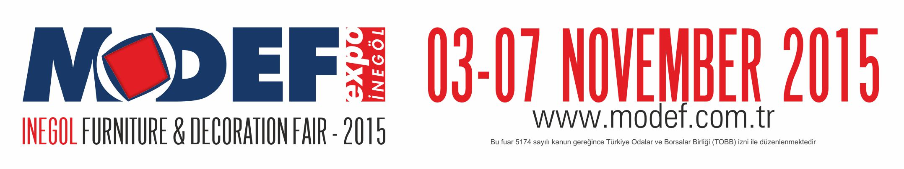

PERSONAL & COMPANY INFORMATION (Please complete ALL fields in capital letters):
Company Name: |  | (Attach your business card)
Name: |  | (Attach your business card)
Title: |  | (Attach your business card)
Address: |  | (Attach your business card)
Country: |  | (Attach your business card)
Tel: Fax: |  | (Attach your business card)
E-mail: |  | (Attach your business card)
Web: |  | (Attach your business card)
COMPANY PROFILE (please tick ALL that apply):
Designer___ Importer___ Exporter___ Wholesaler___ Manufacturer____ Retailer___ Buying Group___
Association___ Agent___ Distributor___ Other/ __________________________________________ __(Please Specify)
If your company is a retailer, how many shops do you have? In your country: ……. shops Abroad: ……. shops
If your company is a manufacturer, how many factories do you have? In your country: ……. Abroad: ……. factories
How many employees do you have in your company? …….
How many countries do you cover? ....................................................................................................................
Revenue (last year): ……………………… USD Revenue growth (last year/year before): ………… %
Please make a summary of your existing business activities within the furniture industry in your country and abroad.
..........................................................................................................................................................................................
INTERESTED FIELD OF ACTIVITY (please tick ALL that apply):
Modern Furniture | Classic Furniture
Sitting Groups  Armchairs and Sofas  Baby, Child and Teenager Rooms | Wood and Modular Furniture  Dining & Bed Group  Single Decoration Accessories
Others: (Please Specify) :................................................................................................................................................

ΑΠΟΣΤΟΛΗ ΦΟΡΜΑΣ: | info@etee.gr

