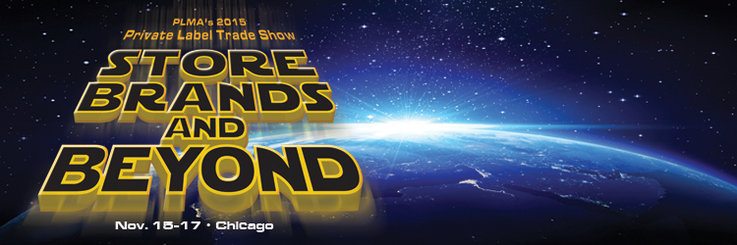

Show Title: PLMA’S 2015 Private Label Trade Show

Show Sponsors: Private Label Manufacturers Association

Show Dates: November 15-17, 2015

Show Location: Rosemont Convention Center
5555 North River Road
Rosemont, IL 60018
847-692-2220

Show Hours: Food, Non-Food and Sky Hall
Monday, November 16th 9:00 am – 6:00 pm
Tuesday, November 17th 9:00 am – 4:00 pm

Who Exhibits: Manufacturers and Suppliers featuring new and traditional food or nonfood products and/or services offered from the US and abroad.

Food Hall
Manufacturers of private label products:

Categories include bakery, beverages, candy, canned foods,
cookies and crackers, dairy, desserts, dressings and oils,
frozen and refrigerated foods, fresh produce, packaged and
prepared foods, sauces, seasonings, condiments, spices and pet.

Non-Food Hall
Manufacturers of private label products:

Categories include health and beauty care – baby care,
cosmetics, feminine and adult care, first aid, hair care, health
care, OTC and vitamins, skin care, and toiletries; apparel and accessories; general merchandise and leisure; household,
housewares & DIY and pet accessories.

Food and Non-Food Halls
Suppliers of services to manufacturers of private label and store
brand retailers.

Categories include product development, package design & graphics, sustainability, packaging materials, shelf allocation software, supply chain efficiencies, market research, marketing services, quality control & testing, and technology.

Exhibiting
Countries Represented: USA, Argentina, Australia, Belgium, Bulgaria, Canada, China, Chile, Colombia, Costa Rica, Czech Republic, Dominican Republic, Denmark, Ecuador, Egypt, Faroe Islands, France, Germany, Greece, Hong Kong, India, Indonesia, Ireland, Israel, Italy, Jamaica, Japan, Latvia, Mauritus, Mexico, Morocco, New Zealand, Nicaragua, Peru, Philippines, Poland, Saudi Arabia, South Africa, South Korea, Spain, Taiwan, Thailand, The Netherlands, Turkey, United Arab Emirates, United Kingdom, Vietnam.

2014 2013
Exhibiting Companies: 1,334 1,233

2014 2013
Total Booths: 2,743 2,534

2014
Registered Visitors: 4,800+

Net Exhibit Space: *1,000,000 Gross Square feet
*274,300 Net Square Feet
*Voted “Top 100 Trade Show”, Trade Show Executive Magazine
*Ranked “Fastest 50 Trade Shows of 2013”,
Trade Show Executive Magazine

2014 Industry Statistics:

$112.2 billion in U.S. private label sales across all retailing channels as measured by The Nielsen Company.

Since 2010 annual growth of store brands outpaced national brands in all outlets, including supermarkets, drug stores, mass merchandisers, club stores, limited assortment, dollar stores and military exchanges. In supermarkets along, Nielsen reports private label sales over the period grew by $5.2 billion or 9.4%.

Store brands outperformed national brands in dollar volume growth for the six consecutive year.

2014 Private Label Trade Show Figures:

PLMA Member Exhibitors Manufacturers 92%
Food………………………… 71%
Non Food…………………… 21%

Trade Suppliers 8%

Retail Buyer Attendance
National, Regional, International and Independent Chains

Retailers 49%
Supermarkets…………………………29 %
Drug Chains….………………… ……. 7 %
Mass Merchandisers…………………13%

Wholesalers/Distributors 25%

Other 26%
.

Show Management: Private Label Manufacturers Association
630 Third Avenue, 4th Floor, New York, NY 10017

212-972-3131

Future Show Dates: November 13 – 15, 2016

